* **T*:** It is read as ‘pointer to T’. A variable of type T* can hold the address of an object of type T.

* **Dereferencing**: The fundamental operation on a pointer. Refers to the object pointed to by a pointer. Also called **indirection.**

* To store smaller values more compactly, one can use bitwise logical operations, bit-fields in structures, or a bitset.
* * as a prefix is a dereferencing operator.
* * as a suffix means ‘pointer to’ a type name.

* **void*:** Read as ‘pointer to an object of unknown type’. Used when we occasionally need to store or pass along an address of a memory location without actually knowing what type of object is stored there.
* A pointer to any type of *object* can be assigned to a variable of type *void\**, but a pointer to a *function* or a *pointer* to a member cannot.
* A *void* can be assigned to another void.
* *void\**s can be compared for equality and inequality.
* A *void\** can be explicitly converted to another type.
* In general, it is not safe to use a pointer that has been converted to a type that differs from the object being pointed to. Consequently, the notation used, *static_cast* was designed to be ugly and easy to find in code.

* Occurrences of *void\**s at higher levels of the system should be viewed with great suspicion because they are likely indicators of design errors.
* Before nullptr was used, 0 was used to denote nullptr.

* Also, it has been popular to define a macro NULL to represent a null pointer. However, definitions of NULL are different in different implementations.
* In C, NULL is typically (void*)0, which makes it illegal in C++.



* Using nullptr makes code more readable than alternatives and avoids confusion.
* **T[size]**: An array of size elements of type T.
* The elements are indexed from 0 to *size-1*.
* The number of elements in the array, the array bound, should be a constant expression.

* If what one wants is a simple fixed-length sequence of objects of a given type in memory, an array is the ideal solution. For any other need, an array has serious problems.
* Arrays can be allocated statically, on the stack, or on free store.

* Avoid arrays in interfaces, e.g. as function arguments, because implicit conversion to pointer is the root cause of many errors in C code and C-style C++ code.
* If an array is allocated on free store, be sure to *delete[]* its pointer once only and only after its last use.
* One of the most widely used kinds of arrays is the zero-terminated array of *char*, also called C-style string.
* Often a *char\** or a *const char\** is assumed to point to a zero-terminated sequence of characters, even in C++.
* An **array** can be **initialised** by a list of values.
* When an array is initialised without a specific size but with an initialiser list, the size of the array is calculated by counting the number of elements in the initialiser list.
* If the size is explicitly specified, it is an error to give surplus elements in an initialiser list.

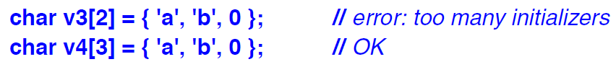

* If the initialiser supplies too few elements for the list, the rest is populated with zero.

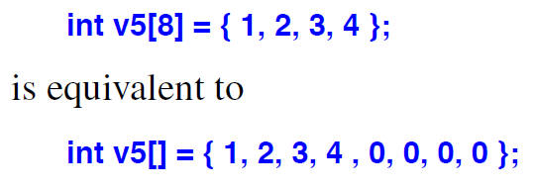

* There is no built-in copy operation for arrays.
* One array cannot be assigned with another, not even of exactly the same type.
* There is no array assignment.



* Arrays cannot be passed by value.
* **String literal:** A character sequence enclosed within double quotes.
* A string literal contains one more character than it appears to have. It is terminated by the ‘\0’ character with a value 0.
* The type of string literal is ‘an array of appropriate number of const characters.’

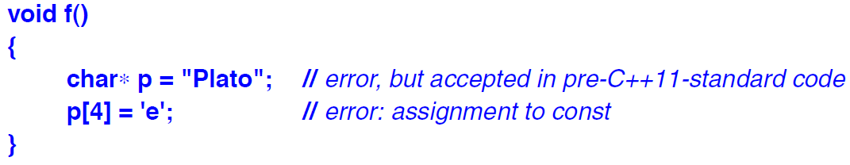

* Whether two identical string literals are allocated as one array or as two is implementation-defined.

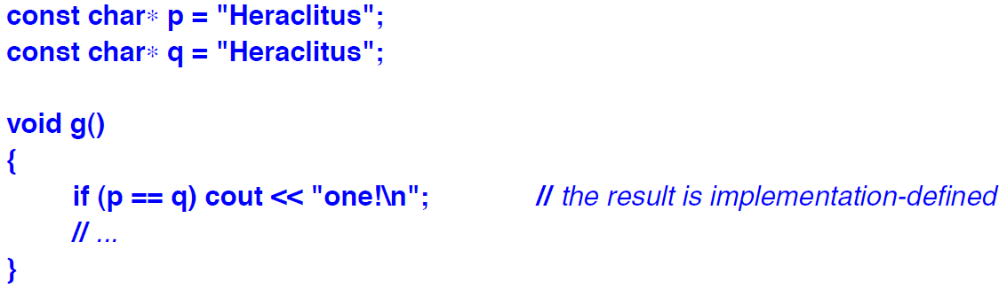

* The empty string is represented as a pair of adjacent “” and has the type const char[1]. The one character is ‘\0’.
* The backslash convention makes it possible to use characters such as double quotes (“) or backslash (\) within a string.
* It is mostly used to represent non-graphic characters, such as \n (newline) or \a (alert with a beep sound).
* Long strings can be broken by white space to make the program neat. The first example is wrong whereas the second is correct.

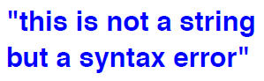

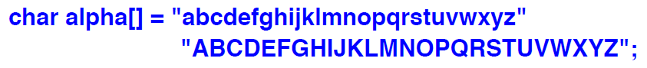

* It is possible to have null character in a string but most programs will ignore any characters after it. For example, “Khazad\0Dum” will be read as “Khazad” by functions such as strcpy() and strlen().
* **Raw string literal:** A string literal where a blackslash is just a backslash and a double quote is just a double quote.



* We can add personalised delimiters before and after () in a raw string.

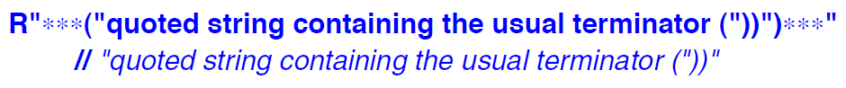

* Unless one works with regular expressions, raw string literals are probably just a curiosity.



* In contrast to non-raw string literals, raw string literals can be spread over multiple lines.

* **Larger Character Sets**
* A string with a prefix L, such as L”Dumbledore”, is a string of wide characters. Its type is *const wchar_t[]*.
* A string with prefix LR, LR”(Gandalf)”, is a raw string of wide characters. Its type is also *const wchar_t[]*.
* Such strings are terminated by L’\0’.
* There are 3 major encodings of Unicode: UTF-8, UTF-16, UTF-32.
* UTF is a variable length encoding. Common characters fit into 1 byte, less frequently used characters into 2 bytes, and rarer characters into 3 or 4 bytes.
* In particular, ASCII characters fit into 1 byte with the same encodings.
* The various Latin alphabets, Greek, Cyrillic, Hebrew, Arabic and more into 2 bytes.
* A UTF-8 string is terminated by ‘\0’. UTF-16 string by u’\0’. UTF-32 string by U’\0’.
* An ordinary English character can be represented in a variety of ways. All these strings will look the same, but the representations will differ.

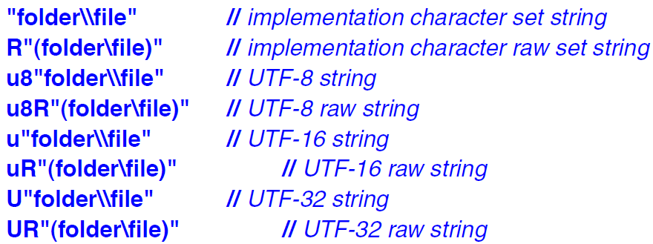

* The order of u and R and their cases are significant when denoting raw Unicode strings.
* **Pointers into arrays:** The name of an array can be used as a pointer to its initial element.

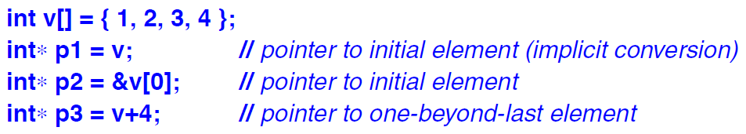

* Taking a pointer into the element one beyond the end of an array is guaranteed to work.

* The result of taking the address of the pointer before the first element of the array and after the one-past-the-last element of the array is undefined.

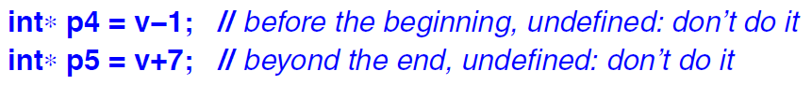

* The implicit conversion of the array argument to a pointer means that the size of the array is lost to the called function.
* This problem is handled by standard library types, such as vector, array, and string, which give number of elements as their *size()* without having to count the number of elements each time.
* **Navigating arrays:** Access can be achieved either through a pointer to an array plus and index, e.g. *a[i]*, or through a pointer to an element, e.g. *\*(p+2)*.
* No one version is faster than the other. It’s simply a matter of the programmer’s preference and aesthetics.
* For every integer array a and an integer j within the range a, we have –



* Equivalences like *a[j] == j[a]* are pretty low-level and do not hold for standard library functions such as *vector* and *array*.
* Subtraction of pointers is defined only when both pointers point to elements of the same array. q-p refers to the range [p:q) of the array, if the range is valid. Otherwise, it is undefined.
* One can add/subtract an integer from a pointer, resulting in a new pointer. E.g. *q = p+2*, *r = p-2*.
* The array concept is inherently low-level. Safer alternatives are *array* and *vector*.
* **Multi-dimensional arrays:** Represented as arrays of arrays.



* Multi-dimensional arrays cannot be declared using commas in C++.

* **Passing arrays –**
* Arrays cannot be directly passed by value in functions.
* In order to avoid confusions related to dimensions, it is best to use the standard library *vector*.
* **Pointers and const –**
* Many objects don’t have their values changed during initialisation –
* Symbolic constants lead to more maintainable code, rather than using literals in the code directly.
* Many pointers are often read through but never written through.
* Most function parameters are often read but never written to.
* For all the above cases, *const* objects is a good choice.

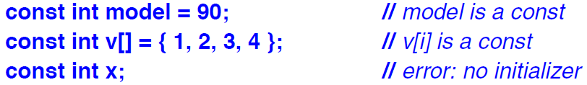

* Since a *const* object cannot be assigned to later in the program, it must definitely be initialised during the declaration process.
* **Prefixing** a declaration of a pointer with *const* makes the object, but not the pointer, a constant.
* To declare a pointer itself, rather than the object pointed to, to be constant, we use *\*const*.

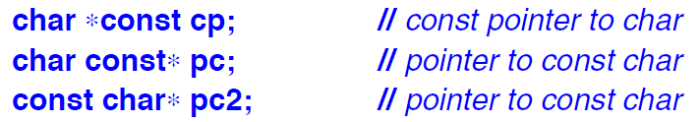

* **Pointers and ownership –**
* A resource is something that has to be acquired and later released. E.g. –
* Memory acquired by *new* and released by *delete*.
* Files opened by *fopen()* and closed by *fclose()*.
* This can be most confusing because a pointer can be passed around in the system and there is no way to distinguish between an pointer which is in ownership and a pointer which is not.
* The standard library unique_ptr, vector, and string are the best to use in this regard.
* A pointer allows us to use potentially large amounts of data at a low cost.
* However, using a pointer differs from using the name of the object in various ways –
* Syntax used is different. E.g. *p vs ob, p->m vs ob.m, etc.
* A pointer can be made to point to different objects at different times.
* A pointer can be a *nullptr* or point to an object that wasn’t expected.
* **Reference:** An alias for an object.
* A reference differs from a pointer in the following ways –
* A reference can be accessed exactly with the same syntax as the name of the object.
* A reference always refers to the object to which it was initialised.
* There is no ‘null reference’.
* The main use of references is for specifying arguments and return values for functions.
* There are three kinds of references –
* *lvalue reference*: To refer to objects whose value we want to change.
* *const reference*: To refer to objects whose value we do not want to change.
* *rvalue reference:* To refer to objects whose value we do not need to preserve after we have used it.
* Notation X& means **‘lvalue reference of X’.**

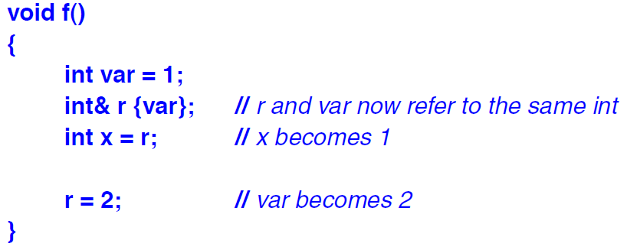

* To ensure that a reference is a name for something, we must initialise the reference. Otherwise, it will throw an error.
* No operator operates on a reference.

* ++r does not increment the reference itself. It increments the value to which the reference is pointing.
* The value of a reference cannot be changed after initialisation.
* We cannot have a pointer to a reference. We can write &rr to get a pointer to the object referenced to.
* References can also be used as return types in cases where a type may be too expensive to copy.
* Having more than one kind of reference is to support different uses of objects –
* A non-const lvalue reference refers to an object, to which the user of the reference can write.
* A const lvalue reference refers to a constant, which is immutable from the point of view of the user of the reference.
* An **rvalue reference** refers to a temporary object, which the user of the reference can modify, assuming that it will not be used again.
* && declarator operator means ‘rvalue reference’.
* We do not use const rvalue references.
* Both a constant lvalue reference and an rvalue reference can bind to an rvalue. But the purposes are different –
* rvalue reference is used to implement a ‘destructive read’ for optimisation. Without it, a copy operation would have been required which can be expensive.
* We use const lvalue reference to prevent modification of an argument.

